# MSIT3860 Data Management for Information Technology

# Term Project Final Deliverable

Keerthi Nivasshini

Clark University

Structural Business Rules

* Every Seller creates a listing of new product or uses an existing listing.
* Each seller sells one or many products; each product has one seller.
* Each product has a category; Every category has many products.
* Each seller ships one or more units of product to seller Inventory; Every product in the inventory has a seller.
* Each customer has one user account access
* Each Customer has one or more address and each address have one customer.
* Each Customer place one or more orders; each orders have one customer.
* Each Purchase by customer have decrement in products from inventory.
* Each order has order details; Each order can have many products.
* Every Package id has one Order ID; Each order may have multiple packages.

The business rules above have entities listed below:

1. Seller
2. Product
3. Product_Category
4. Seller_Inventory
5. Customer_Accounts
6. Address
7. Orders
8. Order_Details
9. Product_Shipment

Conceptual ERD:

por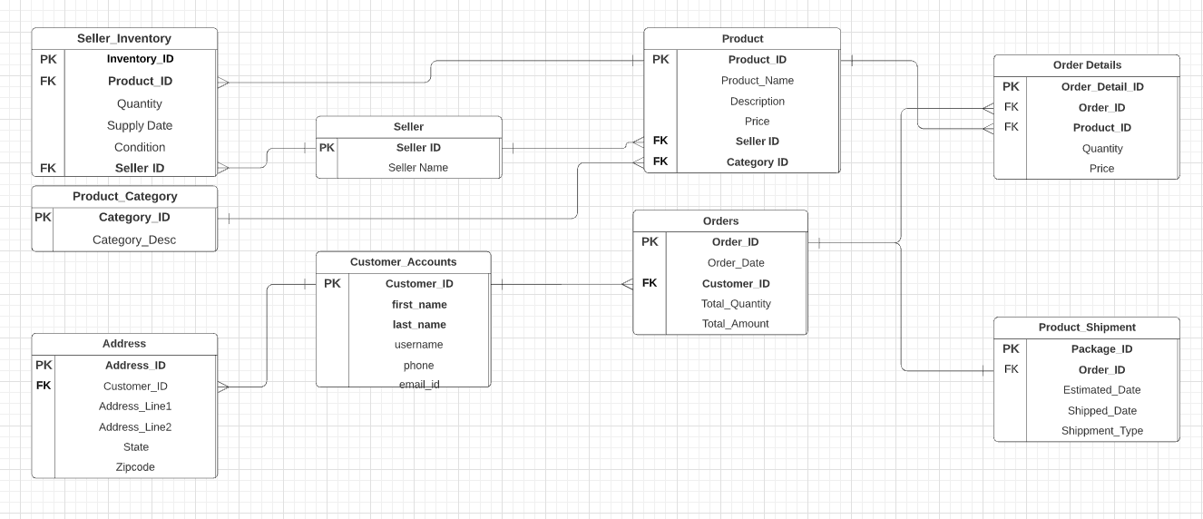

Logical ERD:

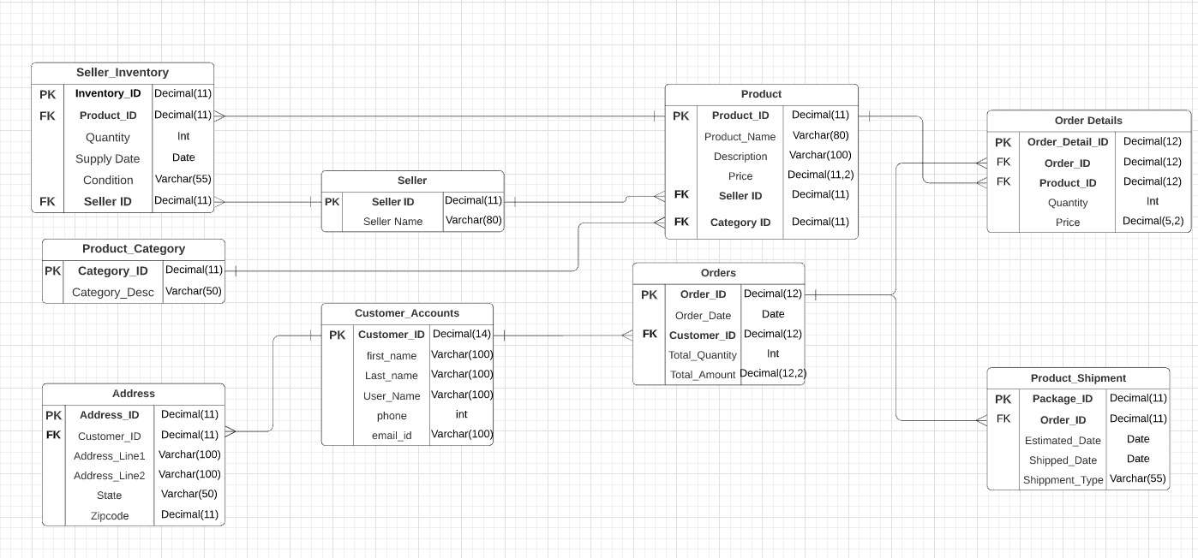

**ASPECT 1**

A)Creating Table:

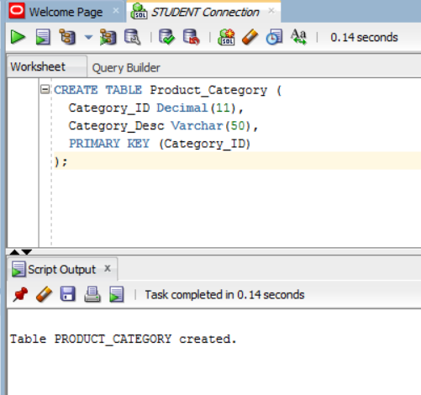

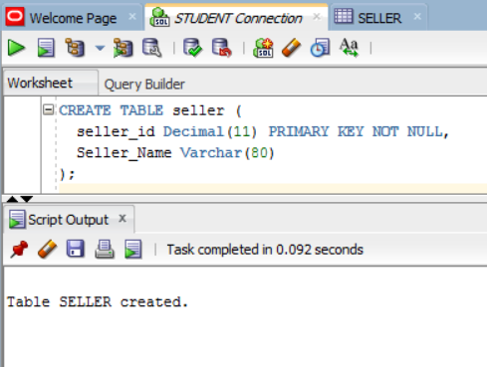

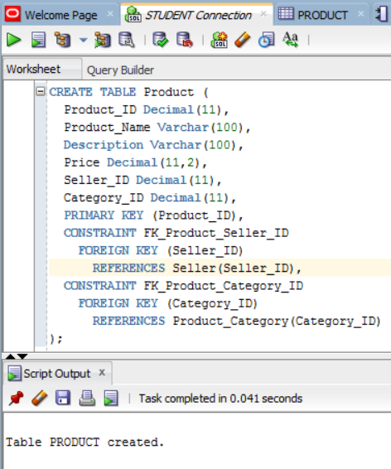

**Inserting into Seller:**

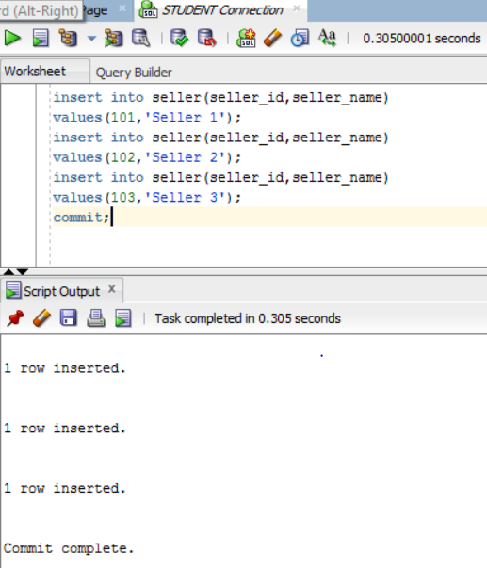

**Inserting in Category:**

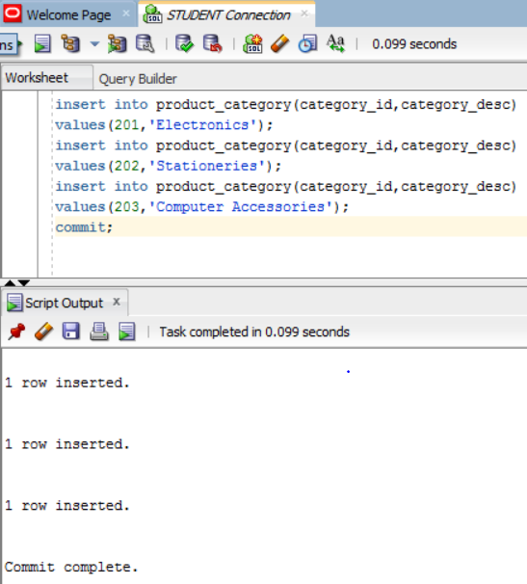

B)Compiling Stored Procedures:

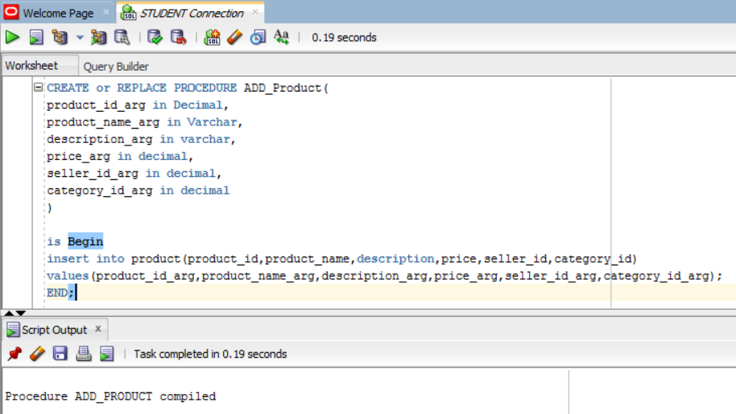

C) Executing Stored Procedures

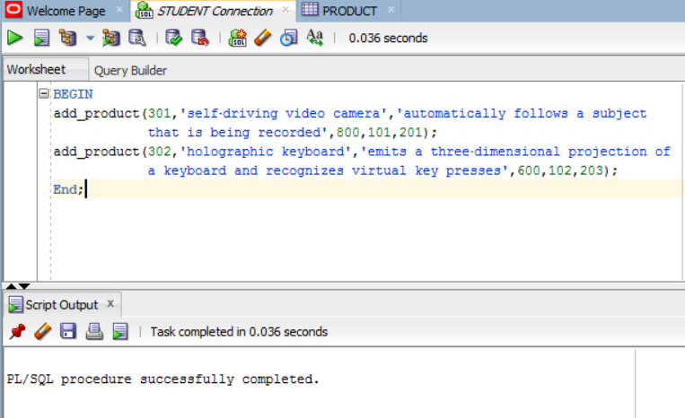

D)SQL QUERY:

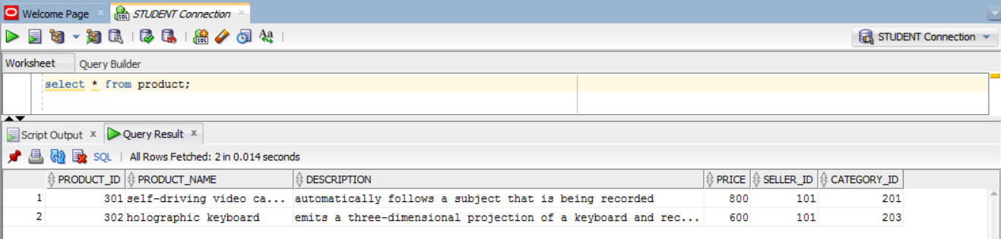

**ASPECT 2**

A)Creating Table:

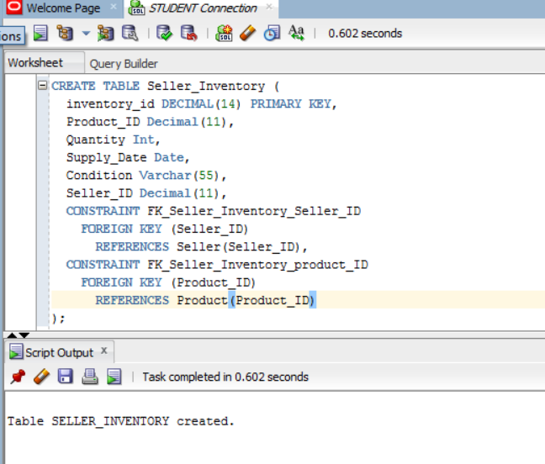

Note*: Seller and Product tables are created in aspect 1 (Select query from aspect 1 is updated and pasted below)



Inserting into Seller_Inventory

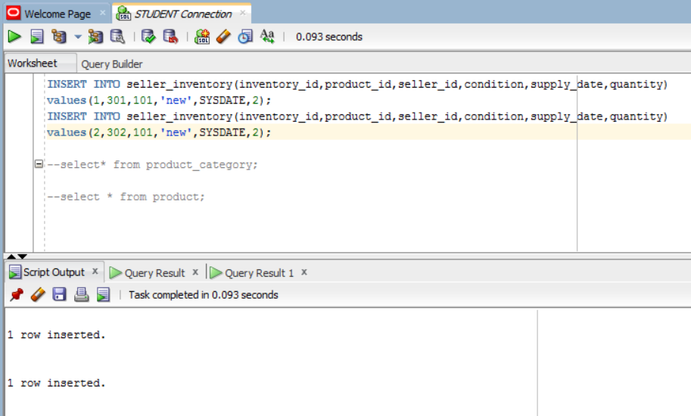

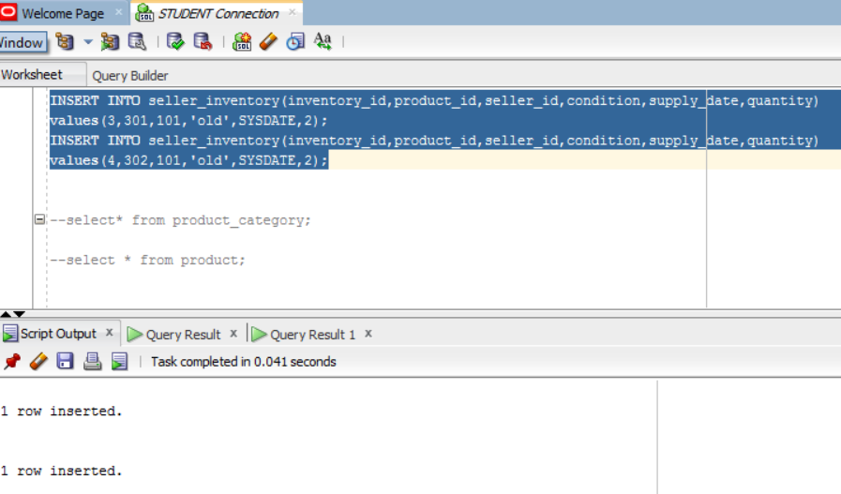

B)Creating Re-usable procedure:

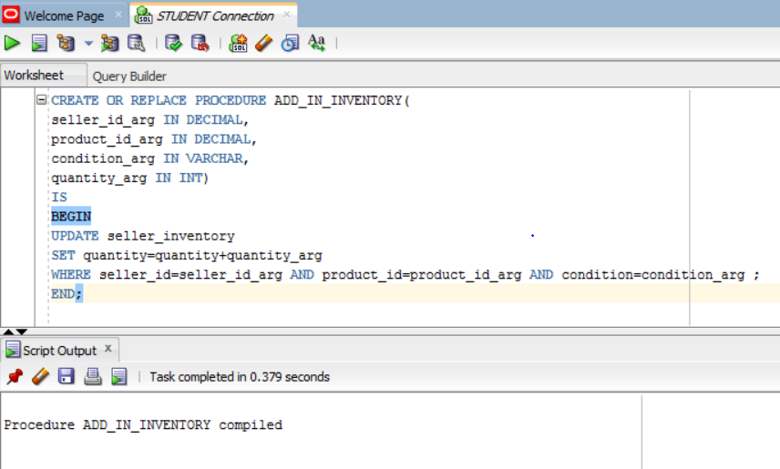

C)Using the Re-usable procedure:

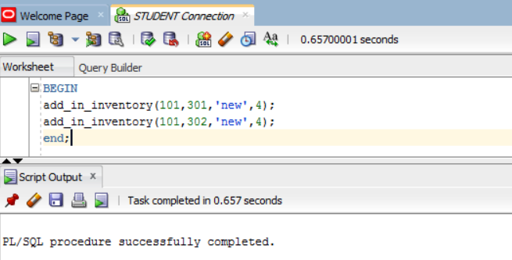

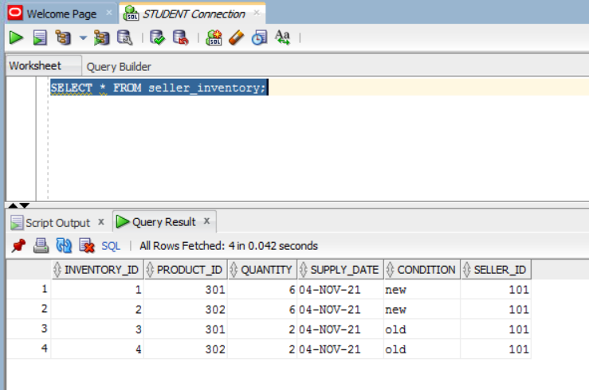

D)SQL Query

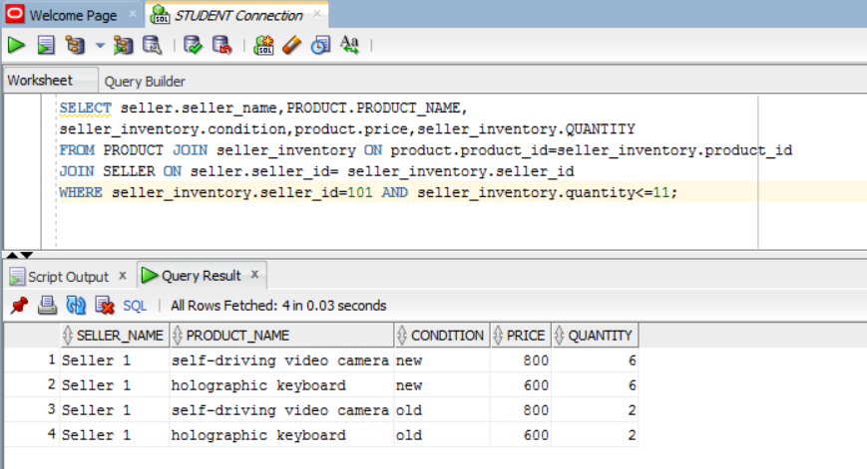

**ASPECT 3**

A) Creating Tables

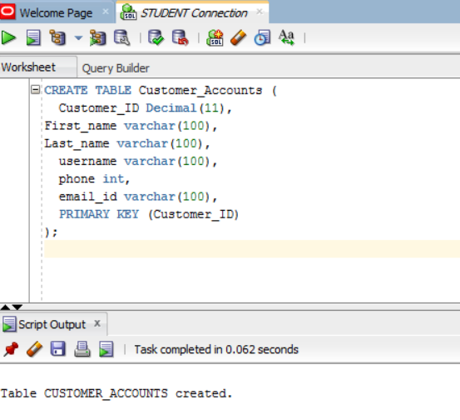

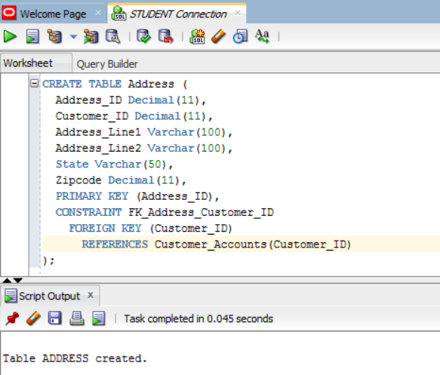

B) Creating Re-Usable Stored procedures:

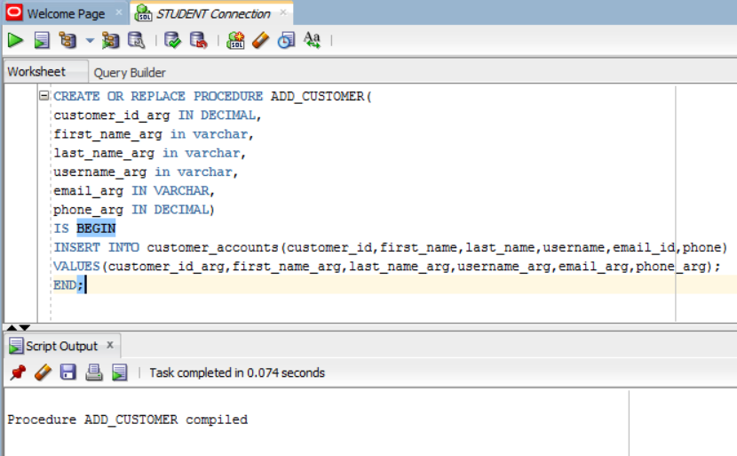

C) Invoking the procedure to add me and my facilitator:

Inserting customers and accounts in customer_accounts table:

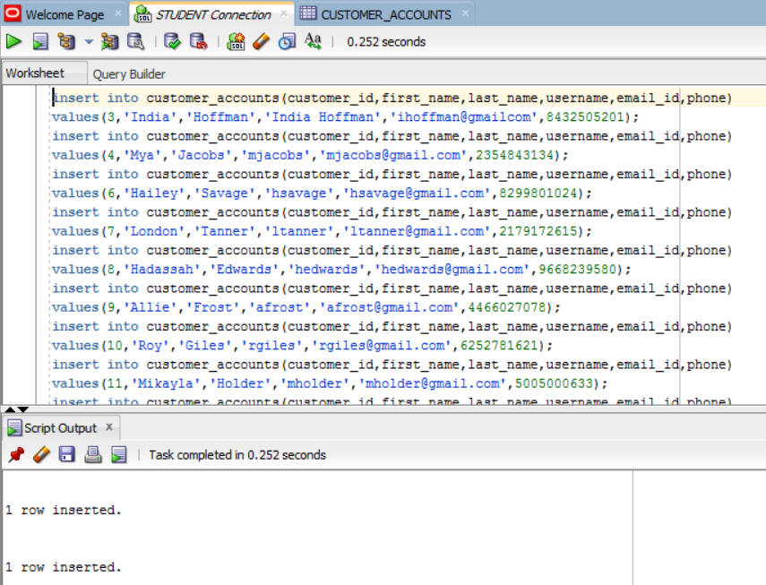

D) SQL QUERY:

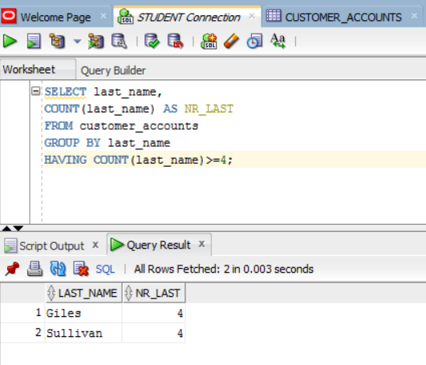

**Aspect 4**

A) Creating Tables

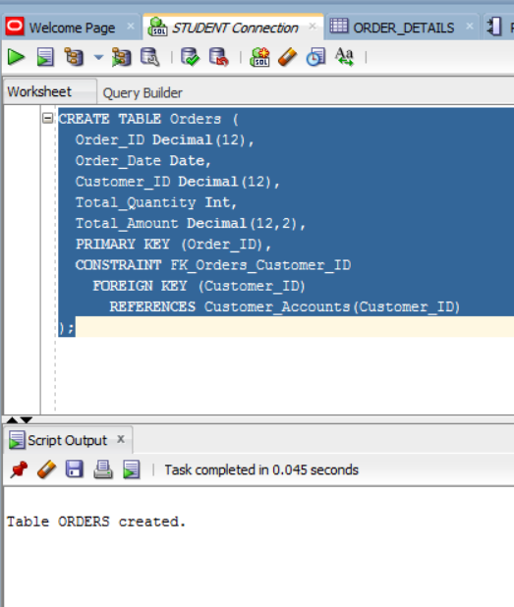

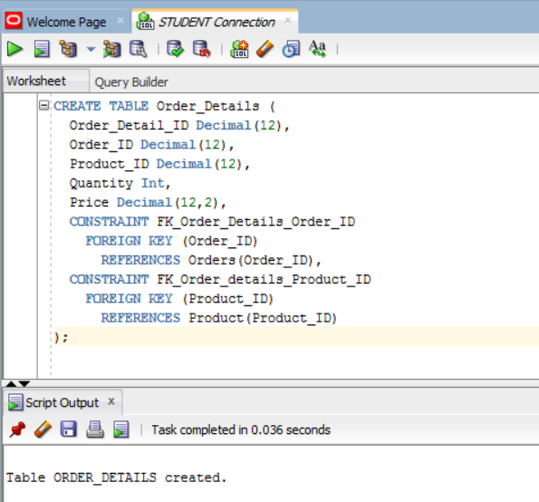

B) Creating Stored Procedure for Product_Purchase:

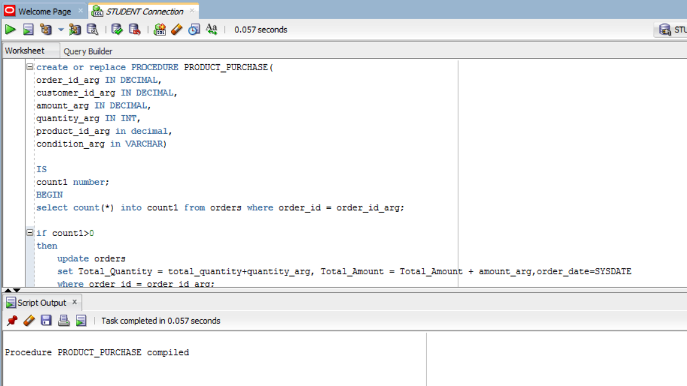

Please View the text file for full stored procedure of Product_Purhase.

**Quantity of the product Before using the stored procedure:**

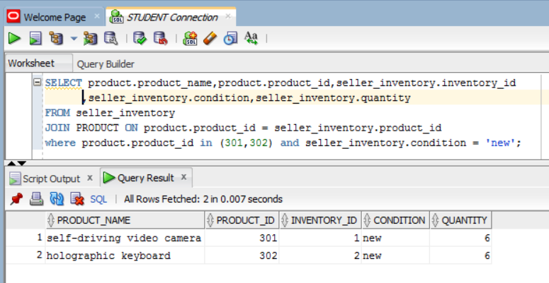

C) Executing the stored procedure:

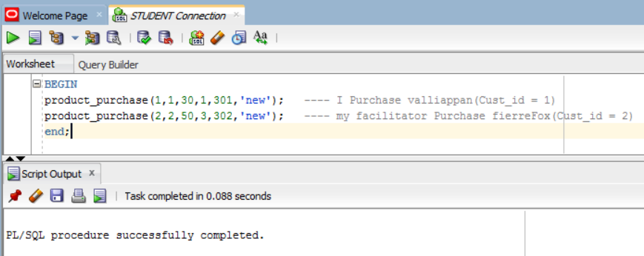

**Quantity of the product after using the stored procedure:**

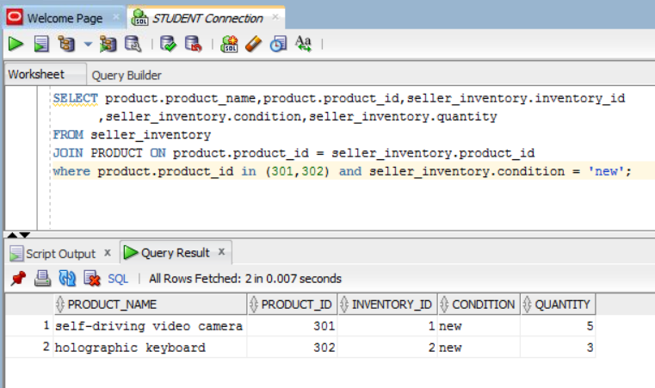

D) SQL Query:

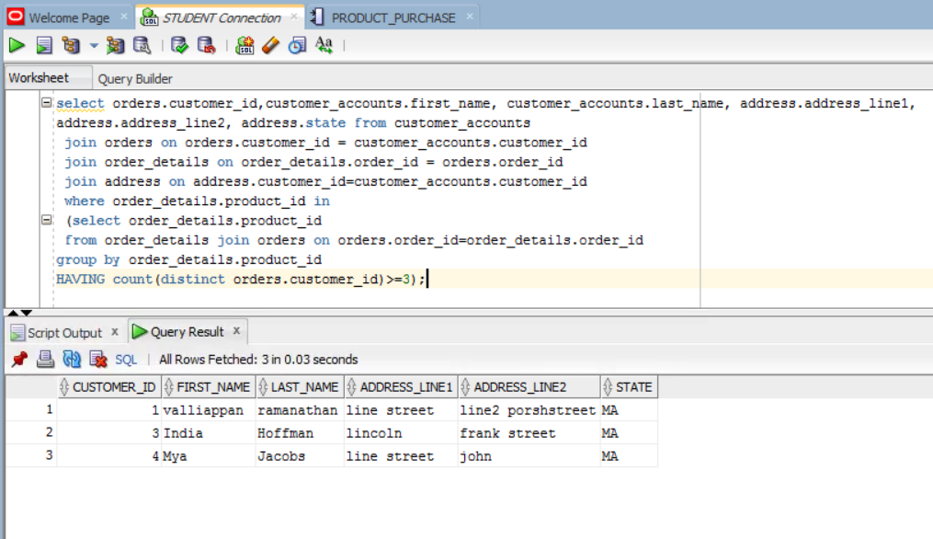

**Aspect 5:**

A) Creating Tables:

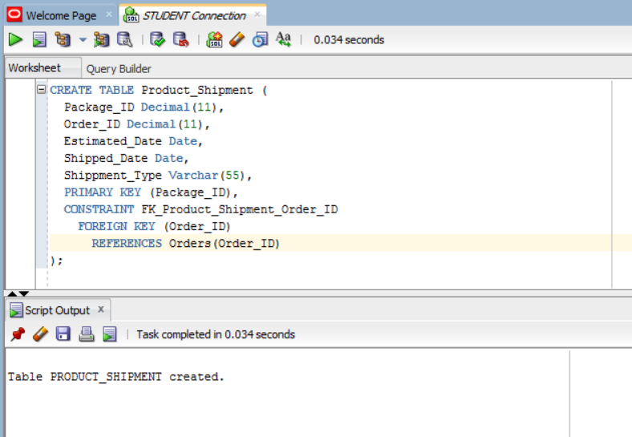

B)Creating Procedure:

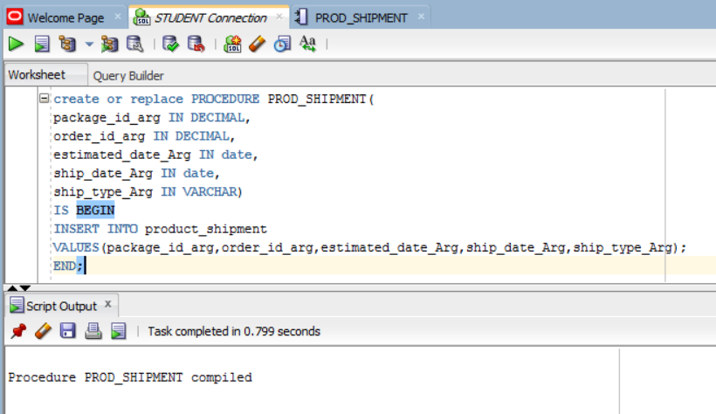

C)Using The Stored Procedure:

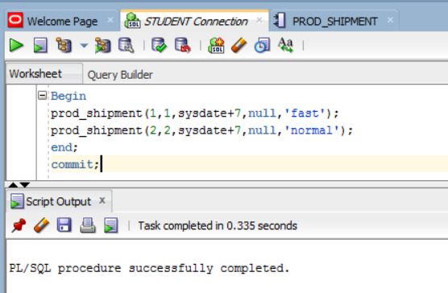

D) SQL QUERY:

**1st Query (Selecting the list of orders and products that are placed in orders)**

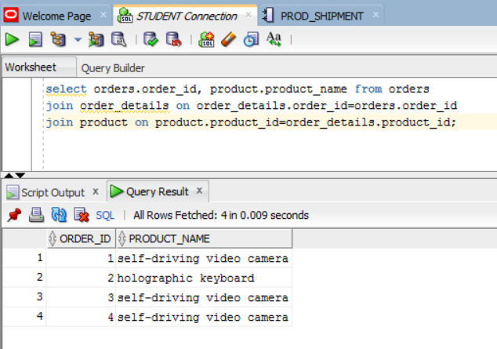

**2nd Query for list of order packages in for shipment:**

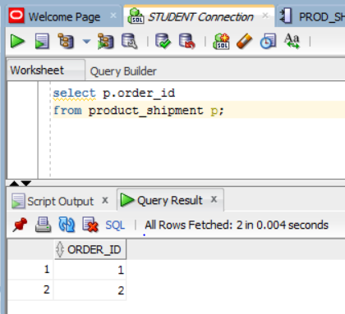

**FullQuery:**

Here for obtaining the list of products that are in for shipment using 2nd query as inner subquery for 1st query as outer main query:

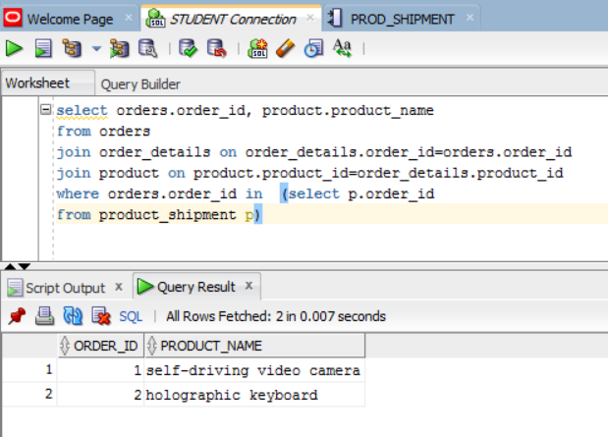

**Index Justification and Creation:**

Here index is created for the column “Total_Amount” in “orders” table.

**Index Creation:**

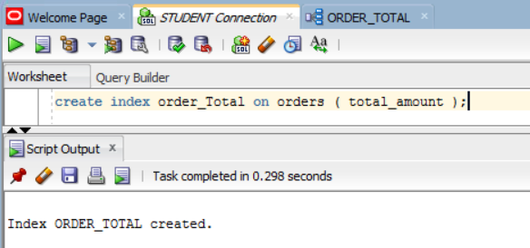

**Index Justification**

If the company management wants to check the orders which has the cost of order less than 50, to improve their business decision and to derive a analysis based on that considering various aspects of price, product, business time period etc.

For example, below is the query applied on the indexed “total_amount” column from orders for the total_amount less than 50. And we get the list of orders which were less than 50 and index helped to retrieve the data sooner.



